November Newsletter – Kids’ Club

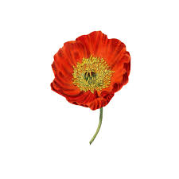
OCTOBER RECAP
We enjoyed the temperate weather we have had this past month. The kids have been busy playing football, basketball, building leaf forts, solving riddles, making awesome crafts and participating in knitting club.
We had a spooktacular Halloween Party on October 31st. Children dressed up in their Halloween costumes, we had face painting by our talented Alina who does crafts with us on Thursdays and we had veggies, fruit, potato chips and ice cream cake while we, watched the movie Transylvania and played games.
Congratulations to Sofia Nuyen (the Queen of Hearts) who won the prize for best costume.

MONTHLY PRIZE
This year we have introduced a monthly prize which goes to the child who has earned the most points during the course of the month. Points are earned for volunteering to clean up, helping others, being kind and respectful to others, good manners, solving the riddle, participating in crafts, trying something new, sharing, and inclusiveness. Points can also be deducted for not playing fairly (ie. giving the riddle answer to others). Congratulations to Heather Geraghty who won the September prize. And congratulations to Evelyne McKinnon who won the October prize.

BIRTHDAYS
This month we will be wishing Oren and Rohan very happy birthdays.

PD DAY NOVEMBER 24th
On October 6th a small group of us went to Saunders Farm to enjoy Halloween at the Farm. We had a sunny, fun filled day getting scared on the Haunted Wagon Ride, navigating through the House of Terror and finding our way through the mazes.
The Ray’s Reptiles PD day has been cancelled because it was not viable with the number of participants who had signed up.

This month we will introduce a new air hockey game, Spirograph, the card game “Things”, UNO, scented slime making, Jenga Quake, beanbag chairs for the quiet room, more books, the game of LIFE and plenty of craft materials to name a few.

All the best,
Sara, Lesli and Mandy

