Kids' Club Communiqué

August 14, 2017
Dear Parents,
Fall 2017
Lesli and I hope you are all having a fabulous summer with your families. The summer has whizzed by for us and we look forward to welcoming your child(ren) back to Kids' Club on Tuesday September 5th.
Please keep in mind that it is your responsibility to ensure you have made the proper arrangements for your children to be dropped off at Kids' Club (48 Nanaimo Drive) by the school buses.

Policies and Procedures
At the request of the QPG Community Association President, over the summer, Lesli and I have been working on updated written policies for a parent handbook and emergency procedures for the Kids' Club. Having these documents prepared and posted on our website will address parental concerns and give clear policies on subjects like snow and PD days. These documents should be up and on our website next week and you will be advised via email.
Health and Safety
There will be 36 children in our program in September 2018. When we are in the park during the fall and spring, there are typically 15-20 other children playing in park over the course of the three hours we are outside. Lesli and I need to be able to identify the children from Kids' Club as they quickly move from spot to spot in the park. We have also had challenges with other children wanting to play with the Kids' Club outdoor toys. In order to address both these issues, we will be ordering light weight mesh sports pinnies for the children to wear over their clothing while they are outside in the fall and spring. The pinnies will be worn over regular play clothes and they will be washed regularly in hot soapy water. Lesli and I would appreciate your support in discussing this with your children as the use of pinnies will become Kids' Club policy in the fall.
Fall can still be hot and humid and with it comes the possibility of sunstroke. When temperatures reach 30 degrees Celsius or over, we will keep the children inside to avoid any potential heat related health issues. When we are outside, Lesli and I strongly suggest your children wear hats or caps to keep their heads protected from the sun. If wearing a hat is not a must for your child, kindly let us know by text, email or telephone and we will not ask your child where his or her cap is.
Starting in September, staff will be doing a sweep of the playground before the children arrive at Kids' Club to ensure there are no hazardous or unsafe materials in the area.

Newsletters and Communiqués
A monthly newsletter will come out the last week of each month to inform parents about the themes, activities, upcoming PD days and celebrations taking place the following month.
Exciting News - We are a HIGH FIVE Registered Organization
We are proud to announce that The Kids' Club is now registered as a HIGH FIVE Registered Organization. Please visit the website address below.
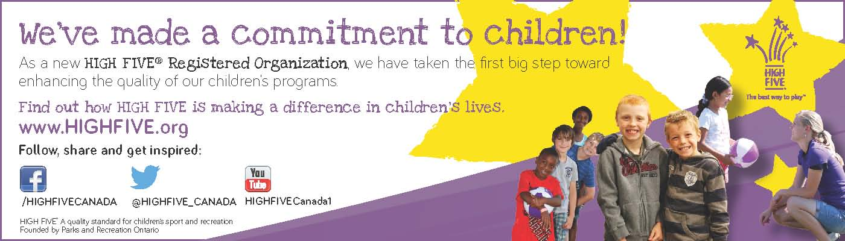
Lesli and I along with some of the teen staff will be taking part one of the High FIVE training on August 16, 2017 at our community centre and once completed, we will communicate how this certification is designed to have an enhanced and positive effect on the children in our program.
Afterschool Snacks
Please be sure to add extra snacks for your child(ren) to have when they arrive at Kids' Club. Most children are a bit famished when they arrive and we are unable to provide them snacks to hold them over until they are picked up at the end of the day.
Youth Staff
You will notice that our youth staff will be wearing t-shirts this fall identifying them as staff. The teens are very excited to have a "uniform" and it makes them feel like they are really part of the Kids' Club team.
Feedback
Lesli and I love hearing constructive feedback from parents. If you have questions, concerns or comments we would be happy to hear from you. The best way to do this is to give us a call at 613-981-5355 or to send us an email at kidsclub@qualicum.org. It is difficult for us to discuss issues with you at the end of the day as we need to keep our eyes on the children who are still in our care.

Sara Ellis Lesli Zanetti
Program Director Assistant Program Director

